OpenDAQ User Manual

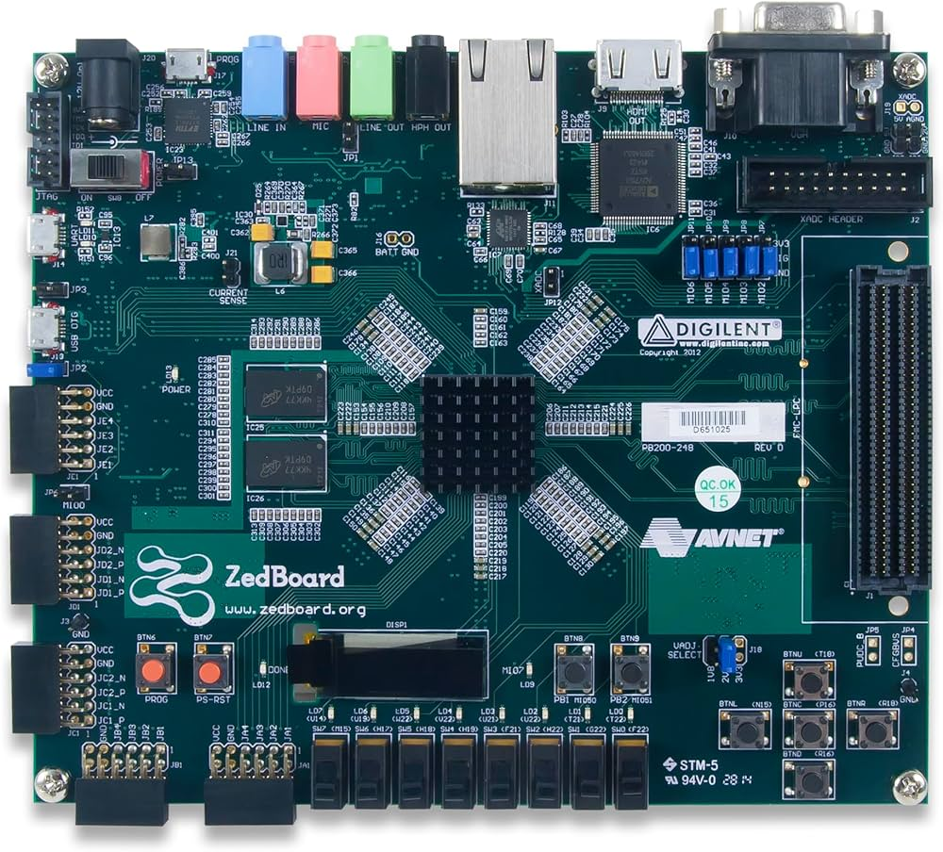
Figure 1. Photo of the FPGA Board.

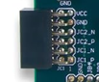
Figure 2. The DAQ input ports.

Important Notes:

- Boot up the FPGA board with the external clock running and connected. (This ensures that the Verilog front end gets flashed properly).
- Do not turn off the external clock until after the csv file has been written. (This gives time for dma transactions to fully finish).
- Delete the oldest csv after 5 data captures to ensure the SD card does not fill up.

JC1P --> CLKP
JC1N --> CLKN
JC2P --> Data P
JC2N --> Data N
JC3P --> Data 2 P
JC3N --> Data 2 N
JC4P --> Data 3 P
JC4N --> Data 3 N
Figure 3. Input Pinout

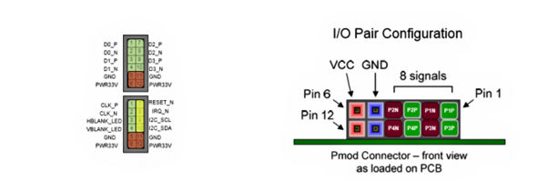
Figure 4. Input Pinout on PMOD connector.

Typical Operating Procedure
- Connect Clock and Data according to pinout.
- Turn on external clock, and ensure that it is running
- Boot up the board (green).
- Connect ethernet (red)
  - Ethernet: ensure that you have a static ip address.
  - ssh petalinux@192.168.1.10 (if not using uart)
- Connect Uart (yellow) – Baud rate 115200
  - Use the Putty program on windows.
- Login
  - User: petalinux
  - Pw : root
- Navigate to the test folder
  - cd test
  - ls (to check rx_test3.c is present)
- gcc -O2 -Wall -Wextra -std=gnu11 -pthread -o rx_test3 rx_test3.c
- sudo ./rx_test3 #words –lsb-first
  - There is a usage guide built into the code for further modifications
  - It is not recommended to change these.
  - To change the length of capture, change the #words in the command.
  - The code cant choose between channels, so it records all 3 even if you only want one, so just look at the relevant column.
- Once the code says “ALL CHANNELS COMPLETE”, then you can turn off the external clock. (Figure 6)
- Send the csv data over the ethernet port
  - Example command:
scp output.csv John@192.168.1.123:"C:\Users\John\Downloads\ "

- For further data captures, repeat step 2, and then repeat steps 9 through 11.
- Delete the oldest csv after 5 data captures to ensure the SD card does not fill up.



Figure 5. FPGA Ethernet port (red) and UART port (yellow), with Power switch (Green).

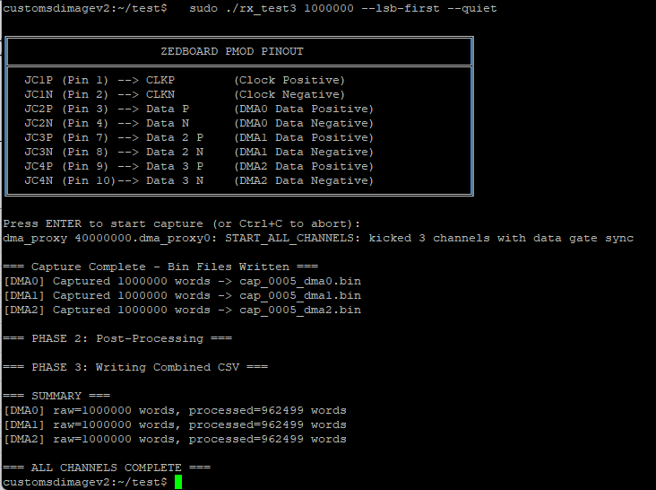
Figure 6. Successful code run display (RED).
(The newer code will also display the first captured and filtered words, but “ALL CHANNELS COMPLETE” is what one should look for before turning off the external clock.)

Link to FPGA User Manual for further information:
[1] https://files.digilent.com/resources/programmable-logic/zedboard/ZedBoard_HW_UG_v2_2.pdf

